**Issues Pertaining to the Lexington Services and Housing Survey**

1. Handling of Open Feedback Comments

Two questions on the survey provided opportunities for open form comments. The direct quotes found in the survey tell heartfelt and powerful stories, and we should honor the time invested in responding. It is important to share these comments with Lexington decision makers and residents to hold up a mirror for the community.

However, one troubling concern is that the specific plan for how to use the quotes in subsequent material was not spelled out in the survey. The survey introduction states: “*Survey analysis will not identify individual responses. Answers will be used in aggregate and to produce correlations across questions*.”

Moreover, it is apparent that a heartfelt comment by one person could be disrespected by another individual, and especially in our era of social media such derision can be very harmful.

**Recommend**:

* Typical use of quotes will not include associated data, such as the person’s income, household status, age, etc. However, exceptions may be made in some limited instances where a survey editor judges the relationship too significant to overlook.
* Our committee will discuss comments in the context of evidence for a particular policy decision, rather than for purposes of personal judgment or amusement.
* Publications which include comments should include a warning about the appropriate use and treatment of comments and expectations of respect.

1. Public Disclosure of Raw Data

Open response answers may contain personally identifying information or other information which in conjunction with other fields might give rise to real or supposed identification for respondents. For example, a respondent might identify their title and employer and that of their spouse, and this information should not be released.

**Recommend**: Free-form fields removed: further elaboration, comments on survey, and source of the survey, should not be shared in full form publicly with the committee nor with members of the public. These fields will remain in the possession of those who conducted the survey for a period of a minimum of 12 months should this recommendation be modified. We plan to examine a process whereby a Lexington staff member would manually redact personally identifying information.

Full release of the data to the committee would seem to constitute public dissemination, and the spirit of the open meeting law would be that data so released should be shared fully with the public unless identifiable harm were identified. Moreover, members of the public may perform additional analysis and draw conclusion which could support or challenge this committee’s conclusions or the use of data by town members.

**Recommend**: Release of all non-open response fields of data for public analysis in the form of a .csv file. (We will also retain the open response field for how the individual heard about the survey since that may be personally identifying in conjunction with the response.)

III. Data Sharing with Town Government Officials

The Lexington recreation director supported this survey and provided specific content and should receive all available data for her staff to analyze. We also will plan to support with technical assistance and initial analysis.

**Recommend**: Data will be shared with the recreation director, and other Lexington staff as requested. Comment fields will not be included unless judged relevant to the intended use.

IV. Proactive Sharing of Data and Analysis

This survey had over 1,340 participants and contains responses which will be valuable across a wide range of public issues. Lexington will appear more responsive with the survey by providing this information early and engaging the community. Furthermore, many survey respondents expressly urged sharing the results with the public.

There may be multiple uses of the survey, and it is possible the town would conduct such surveys on a more regular basis. If such a survey were repeated in the future, it will benefit the town to see multiple distinct uses so residents are motivated to respond to different sections with honesty rather than an agenda to steer a particular policy group. Therefore, we recommend the Policy Exemption Study Committee be identified as one of the users of the survey results.

**Recommend**: At the earliest possible date, release to the public two documents: one providing an overview of all survey questions, reasonable correlations, and sentiment across a wide range of issues; and a second focusing on questions of specific interest to the Residential Exemption Committee. It may be useful to our goal of engagement in the December public hearing if preliminary findings were published well in advance of that meeting, particularly if available to town meeting members and local media outlets in November 2018.

V. Visualization Formats

**Recommend**: Our goals will be to use modern visualization principles with consistency to maximize clarity. These principles include 2-D charts which focus first on dimension, color, and labelling. 3-D charts and pie charts will not be shown due to their limitations for human perception. Colors should be consistenly used for the same theme throughout, and when possible color-blind sensitive colors will be selected.

Primary charts will be displayed with minimal clutter, with a plan for more detailed charts or tables to be provided in backup appendices as applicable.

Response buckets will be sensibly collapsed when the # of respondents in one or more buckets undermines statistical significance or creates high risk of personal identification.

Below are chart examples for the committee to discuss for possible format and color.

Horizontal bar charts are typically preferred for categorical variables other than time, especially as the labels are quite readable for the bars. Numbers are preferentially attached to the bars, but minimally to avoid excessive clutter. When the axis adds no additional information it is omitted.

These draft charts were among a few choices:

1. Show absolute counts within category
2. Show bars sized with absolute counts but marked with % in category
3. Stacked v. Adjacent bars

Since (B) mixed two concepts it proved confusing, and the primary point is to show the change in a given %. In the examples below with two colors stacked, the second color bar might appear extraneous, although it reassures the reader that the category sums to 100%.

While (A) provided the counts, there is enough variation in the survey sample in each row that one cannot see patterns. We reason that survey sample is representative of a larger whole, and the point of the survey is to show the overall trend, and therefore (A) seems inappropriate.

(C) is selected as stacked since summing to 100% is the goal to clearly demonstrate, and adjacent bars would not show the summation as clearly.

Below are examples of charts which might be used in presentation and may be discussed by the committee as examples of possible colors and formats. The figures presented in the diagrams are for illustration purposes and are not final survey figures.

Example of a simplified chart for presentation:

(Labels such as response counts are removed if not essential to the discussion, but reference may be made to a more complete appendix chart.)

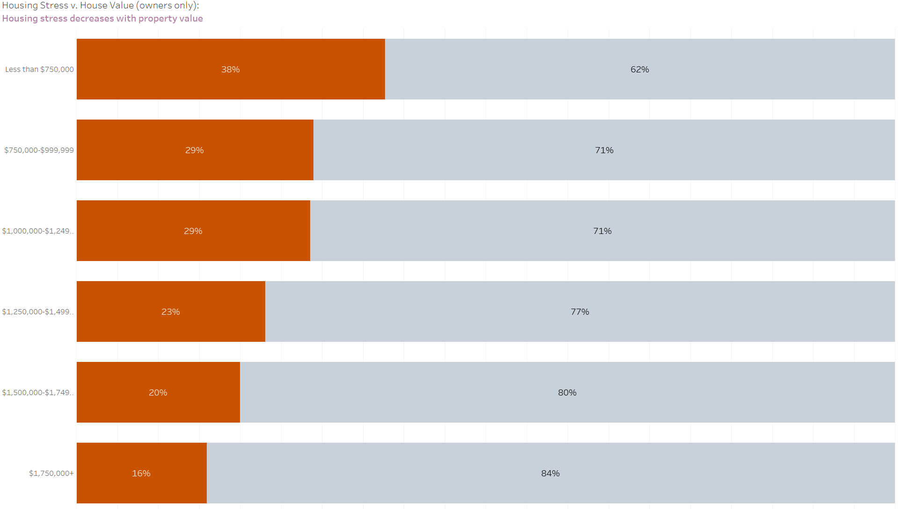

Example of detailed chart typically in an appendix:

(The proposed chart below has both %’s and counts to give the reader a more complete picture of the data.)

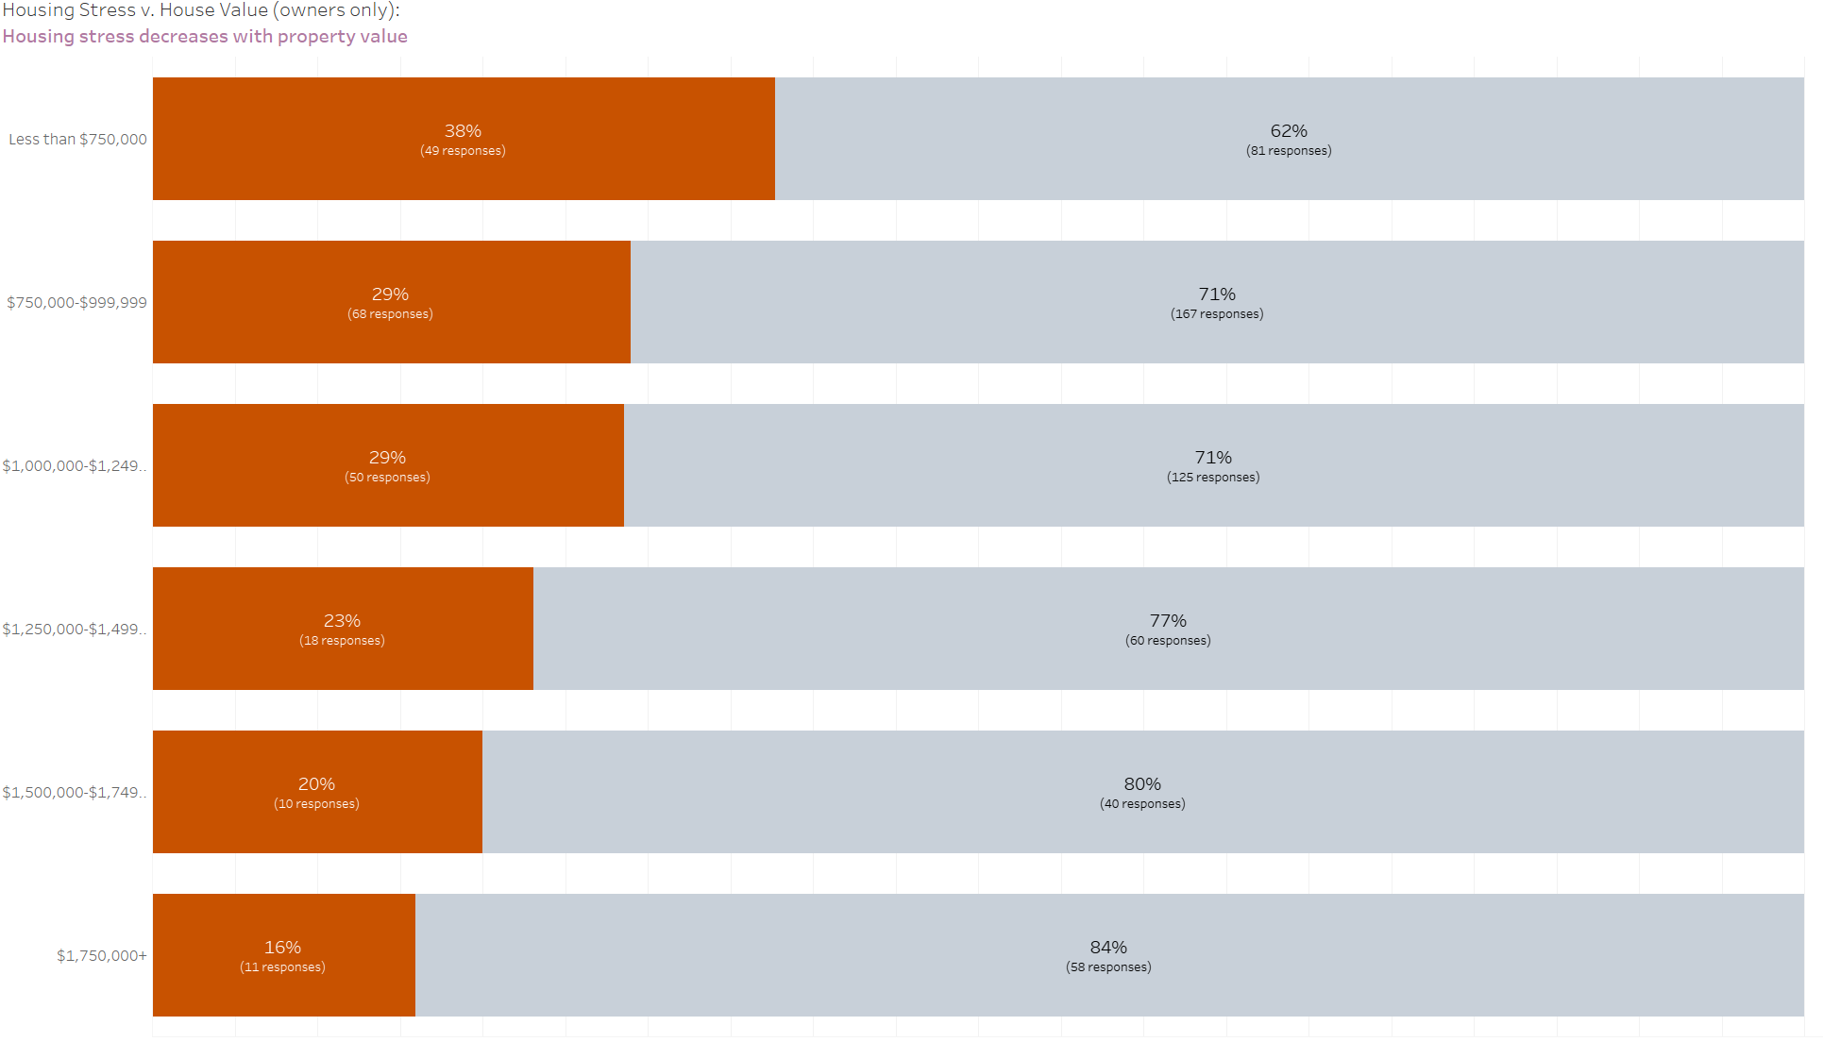

Supporting data may also be shared as a table:

